Please describe the application at a high-level to include the infrastructure? Include physical data center locations, virtualization, cloud services, and whether in the United States?

The PeriWatch Tracings (previously Navicare WatchChild) is an enterprise (multi-facility) capable central surveillance system for OB units including archiving, alerts and documentation. This client-server model system is fully installed at the customer site with no external components. It typically installed at a customer supplied virtual server according to PeriGen provided system specifications.

Is there logical separation of data for CHI? Please explain how this will be done for SaaS solutions?

Not applicable. All data is hosted at CHI.

Please provide a data flow diagram, if available?

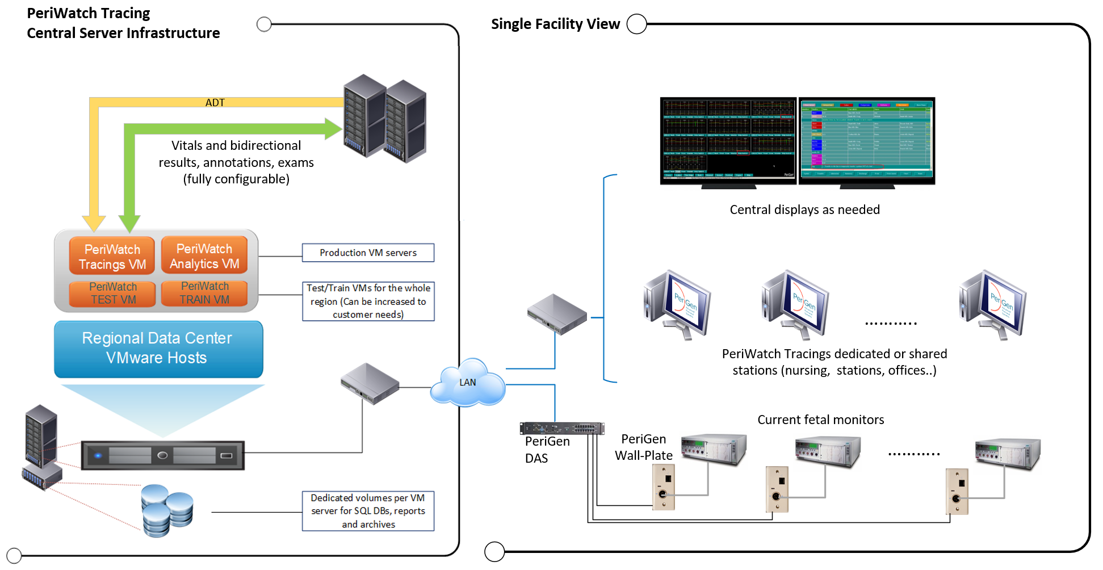

Please describe what remote software tool is used for remote support if required?

SecureLink

Please explain how data in storage is encrypted?

The system is fully hosted by CHI in an SQL database. SQL TDE is supported for full DB encryption. This is applicable as of version 2019.1 of the software.

Please explain how data is encrypted in transit?

All data interfaces between software modules (web services and WCF) are encrypted by SSL certificates provided by the customer. This is applicable as of version 2019.1 of the software.

Is the most secure version of TLS 1.2 utilized for data in transit?

Yes (as of version 2019.1 of the software).

When was the last disaster recovery test performed?

Assuming you are referring to disaster recovery of the CHI instance of the system, this is unclear. Typically, such a task is performed on demand by the customer.

Will CHI have Administrator access, or are these responsibilities handled by the vendor?

Yes. Other than backup tasks that are the responsibility of the customer, there are no other maintenance tasks.

Will CHI have an opportunity to review the application logs?

Yes.

Please provide a high-level review of the SDLC that is followed?
Since the PeriGen system is considered a class II medical device, PeriGen must comply with FDA regulation 21 CFR Part 11 which govern the mandatory guidelines for Document Controls, Corrective And Preventative Actions, Change Control, Quality Management and more.
PeriGen implements all the above as part of an extensive corporate QMS (Quality Management System) which spans the SDLC process. At high level, PeriGen follows an Agile SDLC methodology. Each iteration (2 weeks typically) includes the planned development items (as prioritized by product management as a function of processes mentioned below) and completed test cases. A product release is set as a collection of iterations according to plan. Each iteration includes all aspects of Each release is completed with a QA iteration that includes regression testing and any other relevant validation steps depending on the content of the release.
Formal approval by stakeholder (from management, operations and QA) must be completed before the version can be available for release.

Please provide a high-level review of the Change Management process?

There are two parallel processes governing changes to the product:
- CCB (change control board) is conducted regularly and captures all change requests submitted by customers or internal resources. Items are prioritized and allocated to product maintenance release (or hot-fixes) by patient safety, severity, perceived priority and effort.
- Product Development Roadmap – This higher-level process includes both business and customer priorities for minor and major release plans. The CCB output is used as an input to the overall product roadmap process.

Please provide a copy of the most recent Service Organization Control (SOC) Audit Report for the data center that hosts the solution?

Not applicable. Application is fully CHI hosted.

Where is the secondary and/or backup data center located?

Not applicable. Application is fully CHI hosted.

Will CHI’s data be stored offshore?

No.

How often are vendor scans performed and by whom? When was the date of the last scan?

Each customer performs its own scan of the application according to their internal policies.

Who performs the third party attestations? When was the last review performed?

Planned for Q4 2019.

What specific technology is used to assure redundancy and system availability of the application?

PeriWatch Tracings relies on VMware HA/DRS capabilities as well as MS Clustering (for SQL DB host redundancy)

What are the current system availability SLAs for the application?

Currently, CHI has contracted our 24x7 Extended Service offering.

What are the current backup processes?

Customer is responsible to backup the entire application DB (SQL) according to their internal infrastructure and policies.

What is the data that’s being transferred to you?
NOTE: All data is transferred to the server hosted at CHI only.
- What are data elements (name, dob, address, admit date, etc)?
  - All the above (from ADT) and fetal tracings, associated OB clinical data documented as strip annotations including maternal and fetal vitals.
- How many records will be sent to Perigen​?
  - Each pregnancy/birth is managed by the PeriWatch system. A good rule of thumb is the number of annual births as a basis for the number of records/visits. You should also consider that every birth can span more than 1 visit.
- Will it be a one-time data transfer or regular ongoing transfer?
  - Regular near real-time transfer either manually documented of via HL7 interfaces.

What mechanism will be used to transfer the data?
- Https? FTPs?
  - HL7 via TCPIP connections from your interface engine.
- What is the name (ip) of the sever?
  - 10.82.2.85
- Will the transfer be manual or automated?
  - Regular near real-time transfer either manually documented of via HL7 interfaces.

Where are you keeping the data?
- What is the location of your datacenter?
  - NA. All if hosted at CHI.
- What certifications does the datacenter have? SSAE 16/SOC?
  - NA. All if hosted at CHI.

Once you have the data; how will it be kept secure?
Note: NA. All if hosted at CHI.

- How long would the data sit on your transfer server before it’s removed?
- After it’s been imported and analyzed will the source data be deleted?
- Are your servers file system using full disk encryption?
- Are your databases using encryption?

What is the URL of the portal that will be accessed by CHI?
Note: NA. All if hosted at CHI.

- Will any of the reports contain PHI?
- Is it possible for users to get down to the PHI layer?

How are users authenticated to the web portal?
Note: NA. All if hosted at CHI.

- What are the security control and requirements for portal users?
- Does the portal support multi-factor authentication? (example: id/password + SMS code to cellphone?)

Will reports also be emailed?
- If so, what is source domain for that email? (ex: @ABC.com)
  - No. reports are built into the thick client app.

